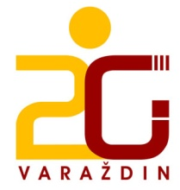

RASPORED ZVONA - 22.09.2016.

1. sat 12.20 – 12.50
2. sat 12.55 – 13.25
3. sat 13.30 – 14.00
4. sat 14.05 – 14.35

VELIKI ODMOR : 14.35 – 14.50

5. sat 14.50 – 15.20
6. sat 15.25 – 15.55
7. sat 16.00 – 16.30

