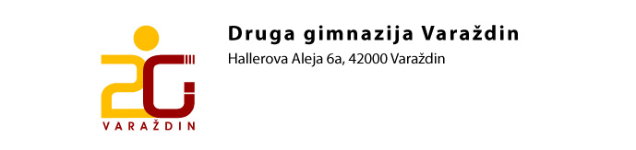
RASPORED ZVONA

1.sat 7.30 – 8.15
2.sat 8.20 – 9.05
3.sat 9.10 – 9. 55
VELIKI ODMOR TRAJE 20 min
4.sat 10.15– 11.00
5.sat 11.05 – 11.50
6.sat 11.55 – 12.40
7.sat 12.45 – 13.30
8.sat 13.35 – 14.20

